




NORTHERN SCHOOL
Figurative Language
Weekly Lesson Plan

Teacher  Add your name here. | Grade Level and Subject  Insert grade and subject here. | Week of  Add date range.


Learning objectives
At the end of the week, learners will be able to:

- Add the ﬁrst learning outcome or skill.
- Another learning outcome or skill here
- Another learning outcome or skill here

Materials and resources

Textbooks | - Add book title here.  - Another book title here  - Another book title here | Use this space for your notes.
Visual aids | - Add a link to a presentation here.  - Another visual aid here  - Another visual aid here | Use this space for your notes.
Other category | - Start your list here.  - Add another item  - List other resources here | Use this space for your notes.


Lesson overview

DAY | TOPIC | ACTIVITIES | NOTES
Monday | Introduction to Heat | Discuss sources of heat; class brainstorm activity  Exit ticket: What are three examples of heat energy? | Reinforce vocabulary before the lesson starts.
Tuesday | Conduction | Demonstrate how energy flows when a metal spoon is placed in hot water; students record observations  Quick Quiz: Five items on conduction | Prepare materials before the demo.
Wednesday | Another topic here | Summarize the the key activities and include a way to check understanding. | Add notes for differentiation or support.
Thursday | Another topic here | Summarize the the key activities and include a way to check understanding. | Add notes for differentiation or support.
Friday | Another topic here | Summarize the the key activities and include a way to check understanding. | Add notes for differentiation or support.

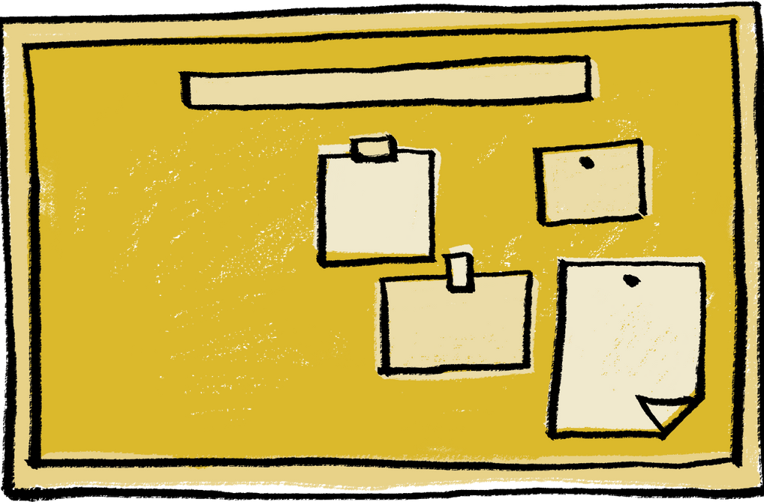
Notes

- Note ideas or changes for next week
- Reﬂect on wins and challenges from this week
- Use this space for anything else

